**Objective Questions:**

1. **What is the distribution of account balances across different regions?**

Since there are high numbers of customers account in France, Germany and Spain. So, the account balances are also high in the following order: France, Germany, Spain.

1. **Identify the top 5 customers with the highest Estimated Salary in the last quarter of the year. (SQL)**

The top 5 customers who have highest number of transactions are Walker with 1529153.9 salary, Mai with 1377265.46 salary, Chu with 1340039.3 salary, White with 1244366.77 salary and Pan with 1146644.1.

1. **Calculate the average number of products used by customers who have a credit card. (SQL)**

From the SQL Query, the customers who have credit card mostly use 2 as their number of products.

1. **Determine the churn rate by gender for the most recent year in the dataset.**

Male has a churn rate of 5.00 and Female has a churn rate of 8.00.

1. **Compare the average credit score of customers who have exited and those who remain. (SQL)**

The customers who have exited has average credit score of 645.35 and customers who have retained in the bank has average credit score of 651.85.

1. **Which gender has a higher average estimated salary, and how does it relate to the number of active accounts? (SQL)**

Female has highest average estimated salary of around 99773.18 even though they are having a smaller number of active accounts than the Male.

1. **Segment the customers based on their credit score and identify the segment with the highest exit rate. (SQL)**

The customer’s credit score has been segmented as Excellent: 800–850, Very Good: 740–799, Good: 670–739, Fair: 580–669, Poor: 300–579. The customer’s having Fair as their credit score worthiness has the highest exit rate of 680 followed by Poor (520), Good (452), Very Good (252), Excellent (128).

1. **Find out which geographic region has the highest number of active customers with a tenure greater than 5 years. (SQL)**

France is the geographic location which has the highest number of active customers of count 797 with a tenure greater than 5 years.

1. **What is the impact of having a credit card on customer churn, based on the available data?**

Totally 1424 customers have exited from the bank who have credit card. But customers with credit card who remained in the bank is higher than the exited people. So, there is no impact of having a credit card on customer churn.

1. **For customers who have exited, what is the most common number of products they have used?**

The exited customers have used 1 as their most common number of products.

1. **Examine the trend of customer exits over time and identify any seasonal patterns (yearly or monthly). Prepare the data through SQL and then visualize it.**

According to the given dataset, the most recent year 2019 have the highest exit rate of customers. And also, the outlier is from the year 2016 to 2019 we are losing customers higher when compared to the previous year.

1. **Analyse the relationship between the number of products and the account balance for customers who have exited.**

The customers who have 4 as their number of products has the highest average of account balance (93733.14) compared to others followed by one product (92028.82), two products (90252.36) and three products (85853.09).

1. **Identify any potential outliers in terms of spend among customers who have remained with the bank.**

The customers who are not having 4 as the number of products are mostly retained in the bank.

1. **Can you create a dashboard incorporating the visuals mentioned above and additionally derive more KPIs if possible?**

As mentioned above, I have created a dashboard and created some KPI’s such as Average customer balance, Average Credit Score, Average Estimated Salary, Maximum and Minimum of all those categories.

1. **Using SQL, write a query to find out the gender-wise average income of males and females in each geography id. Also, rank the gender according to the average value. (SQL)**

By using Dense Rank Function, I have ranked the gender-wise average income of males and females in each geography id.

* First Rank - Female in Germany has average income value 102446.42.
* Second Rank - Female in Spain has average income value 100734.11
* Third Rank - Male in France has average income value 100174.25
* Fourth Rank – Male in Germany has average income value 99905.03
* Fifth Rank – Female in France has average income value 99654.25
* Sixth Rank – Male in Spain has average income value 98425.69.

1. **Using SQL, write a query to find out the average tenure of the people who have exited in each age bracket (18-30, 30-50, 50+).**

The average tenure of the customers with the age bracket of 50+ is 4.8533 which is the highest average tenure followed by the customers with the age bracket of 30-50 is 4.8765, the customers with the age bracket of 18-30 is 4.8226.

1. **Is there any direct correlation between the salary and the balance of the customers? And is it different for people who have exited or not?**

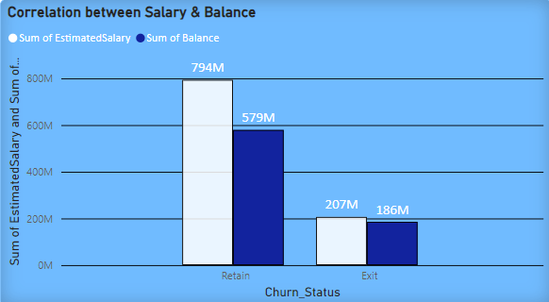

From the above picture, we can get the conclusion as if there is increase in salary for both the retained customers and the exited customers, there is an increase in balance. So, there is a direct correlation between both salary and balance.

1. **Is there any correlation between the salary and the Credit score of customers?**

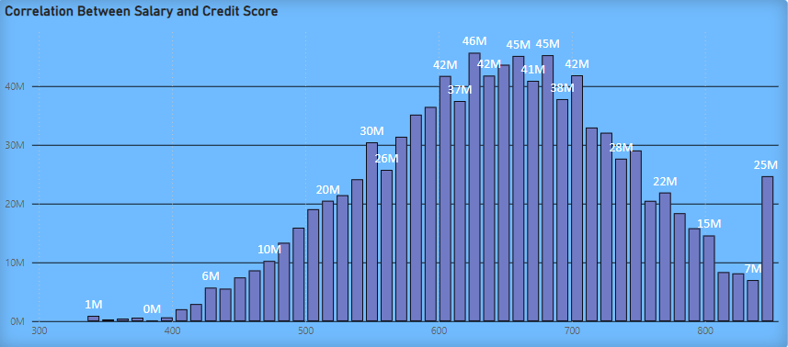

From the column chart mentioned above, we can understand that there is no correlation between salary and credit score.

1. **Rank each bucket of credit score as per the number of customers who have churned the bank.**

I have ranked each bucket of credit score as per the number of customers who have churned the bank in SQL. From that, I got that the Fair Credit card worthiness (i.e.).,580-669 got the first rank with 685 customers followed by Poor Credit card worthiness (i.e.).,300-579 got the second rank with 520 customers, Good Credit card worthiness (i.e.).,670-739 got the third rank with 452 customers, Very Good Credit card worthiness (i.e.).,740-799 got the fourth rank with 252 customers and finally Excellent Credit card worthiness (i.e.).,800-850 got the fifth rank with 128 customers.

1. **According to the age buckets find the number of customers who have a credit card. Also, retrieve those buckets that have a lesser than average number of credit cards per bucket.**

The count of customers with the age bracket 30-50 is 5009 and the count of customers with the age bracket 50+ is 874 and customers with the age bracket 18-30 is 1172. These are all the buckets having lesser than the average number of credit cards per bucket.

1. **Rank the Locations as per the number of people who have churned the bank and the average balance of the learners.**

* Germany got the first rank because of having 814 number of people and average balance of 119730.12 who exited the bank.
* France got the second rank because of having 810 number of people and average balance of 62092.64 who exited the bank.
* Spain got the third rank because of having 413 number of people and average balance of 61818.15 who exited the bank.

**Subjective Question:**

1. **Customer Behaviour Analysis: What patterns can be observed in the spending habits of long-term customers compared to new customers, and what might these patterns suggest about customer loyalty?**

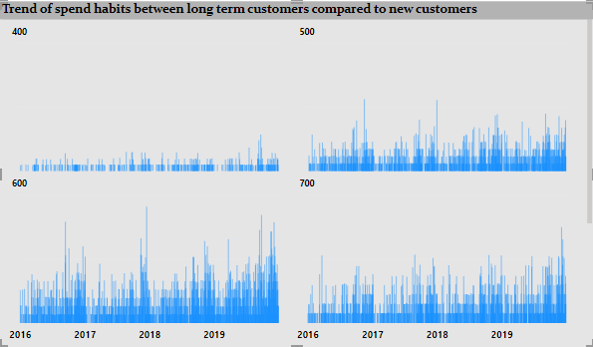

From the above visualization, we can notice that spend habits of the retained customers for the long-term customers are lesser than the new customers so that their credit score are also in the lower manner.

1. **Product Affinity Study: Which bank products or services are most commonly used together, and how might this influence cross-selling strategies?**

Since there are no bank products provided in the datasets, we can’t come to conclusion that which factor influence the cross-selling strategies.

1. **Geographic Market Trends: How do economic indicators in different geographic regions correlate with the number of active accounts and customer churn rates?**

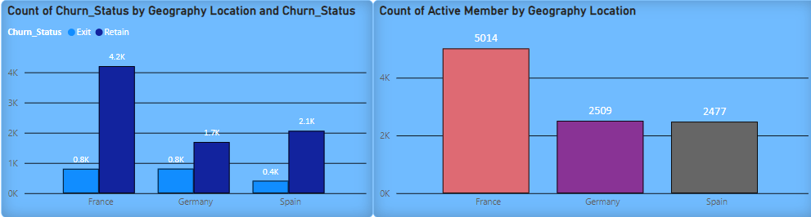

From the above visualisations, we can analyse that the France has the highest number of active accounts and second largest churn rates. On the other hand, Germany has lowest number of active accounts but also the highest churn rates. Spain has the lowest churn rates and second smallest number of active accounts.

1. **Risk Management Assessment: Based on customer profiles, which demographic segments appear to pose the highest financial risk to the bank, and why?**

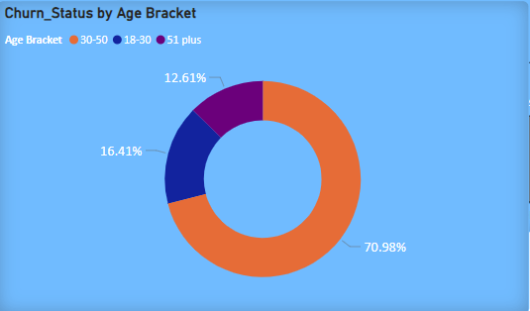

The reason why I choose Age bracket as demographic segment is because age factor is common for both male and female which has high impact on bank’s financial risk. From the above visualizations, middle age bracket people have the highest rate of churn. At the age bracket between 30 and 50, all the people will try to put the investments, but at the time customers are exiting from the bank. It could cause high financial risk to the bank.

**5. Customer Lifetime Value Forecast: How would you use the available data to model and predict the lifetime value of different customer segments?**

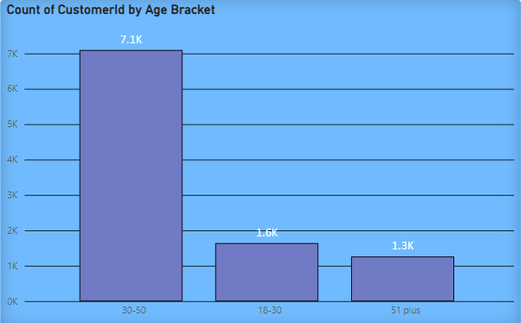

Since the question is asked for the life time value of customer, I have chosen to present the customer count and their life time which is age bracket. By this visual, we can understand that at the age of 18-30 the customer count is very low. Moving to the age bracket of 30-50, customers count is high which seems to be profitable for the bank. And at the age of 50+, Customers are not ready to be in the bank. As per the count of customers the credit score also varying.

**6. Marketing Campaign Effectiveness: How could you assess the impact of marketing campaigns on customer retention and acquisition within the dataset?**

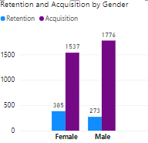

We can say that the acquisition of customer for the last year is higher than the rate of retention for both the male and female. To decrease the retention rate, we may offer some offers on the old customers they could have gain some credit score additionally. So that the new customers also remain for the long period of time.

**7. Customer Exit Reasons Exploration: Can you identify common characteristics or trends among customers who have exited that could explain their reasons for leaving?**

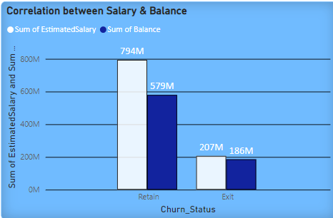

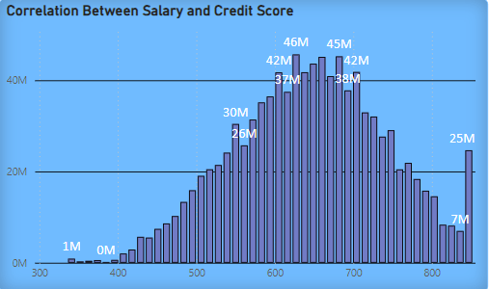

From the above visuals, we can say that the salary and so credit score are the main characteristics or trends among the customers who have exited. Because as the salary is low, they are not able to maintain the credit score. So that they may planned to exit the bank.

**8. Is 'Tenure', 'NumOfProducts', 'IsActiveMember', and 'EstimatedSalary' important for predicting if a customer will leave the bank?**

Yes, Tenure, NumOfProducts, IsActiveMember and EstimatedSalary are important for predicting if a customer will leave the bank. Because these columns will help us to find the customers can buy product with his estimated salary and can settle down the payment within the tenure time and after paying things will he be available as active member in the bank.

**9. Utilize SQL queries to segment customers based on demographics, account details, and transaction behaviours.**

1. **Customers count by Age Group**

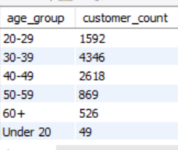

1. **-Count of all customers according to credit score range**

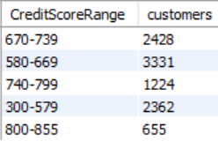

1. **Grography wise customer count.**

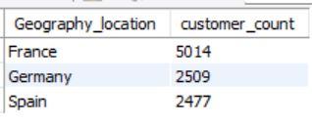

1. **Geography_location wise total balance**

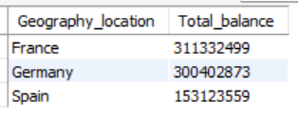

1. **Product wise customer count**

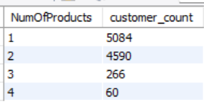

** All SQL queries listed in the SQL file**

**10. How can we create a conditional formatting setup to visually highlight customers at risk of churn and to evaluate the impact of credit card rewards on customer retention?**

|  |  |  |  |
| --- | --- | --- | --- |
| **Count of Customer ID** |  |  |  |
| **Credit Card Status** | **Non Credit Card Holder** | **Credit Card Holder** | **Grand Total** |
| Exit | 613 | 1424 | 2037 |
| Retain | 2332 | 5631 | 7963 |
| **Grand Total** | **2945** | **7055** | **10000** |

In this, we can select the count of Customer Id column an select the conditional formatting which is present in the home tab. In that we can format things according to that data by the MS Excel.

**11.What is the current churn rate per year and overall as well in the bank? Can you suggest some insights to the bank about which kind of customers are more likely to churn and what different strategies can be used to decrease the churn rate?**

**Year wise churn rate :**

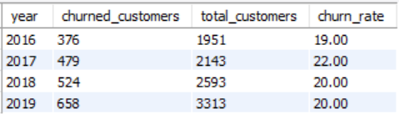

**Overall churn rate:**

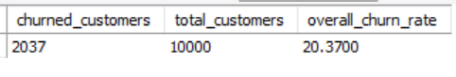

**Number of products wise total customer count and churn rate :**

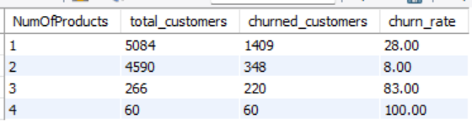

In the year 2017 we can observe that there is a high churn rate with 22 and in 2018 & 2019 churn rate is 20, lastly 2016 has 19 churn rate. Overall churn rate of the bank is 20.37 with 2037 exit count out of 10000 customers. Customers in the 30-50 age bracket exhibit the highest exit count. This group may be experiencing life changes, such as career transitions, family changes, or financial stress, making them more likely to switch banks.. And people who are buying 3 or 4 products we can see high churn rate and also who are buying 1 product there is also exit count is high.

**Recommendations:**

* Increase Tenure period for customers who are buying multiple products.
* Age-Specific offer
* Feedback Collection
* Loyalty and rewards program
* Referral bonus

By implementing these strategies, the bank can reduce churn rates, improve customer satisfaction, and increase overall customer loyalty.

**THANK YOU**